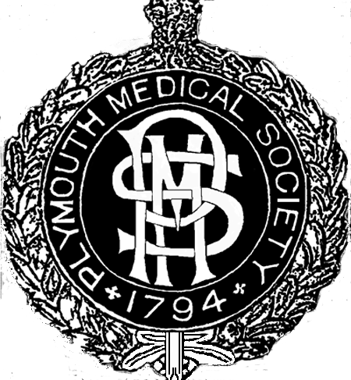
PLYMOUTH MEDICAL SOCIETY

7.30 pm Friday 25 January 2019
Derriford Centre for Health & Wellbeing
(PL6 8DH, next to the Postgraduate Medical Centre)

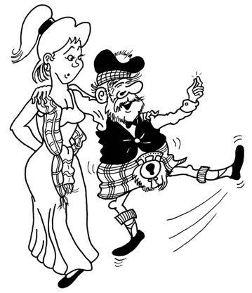
Address to the Haggis

Burns Dinner

Dawntreader
Ceilidh Band

Haggis, neeps & tatties
Piper

or vegetarian alternative
dancing

Pay bar and free cask of beer
Scottish attire or comfortable clothes and shoes
…………………………………………………………………………………………………………
Booking form (please turn over)
Please return this form to Robert Jeffery, Consultant Orthopaedic Surgeon, Level 11, University Hospital Plymouth, Derriford Road, Plymouth PL6 8DH by 11 January with cash or a cheque made payable to “Plymouth Medical Society”. Please indicate overleaf if you or your guests would prefer the vegetarian meal or have any allergies.
Ticket price £35

Special rates:
Groups of six or more – cheapest goes free
Trainees and students £20
Earlybird: before 1 December 2018 - £5 off all tickets

…………………………………………………………………………………………………………

Booking form
Please send me tickets for the Burns Dinner & ceilidh on Friday 25 January 2019.
Names of your guests and yourself: ticket price vegetarian option?
£ yes / no
£ yes / no £ yes / no £ yes / no
£ yes / no sixth goes free yes / no
Total: £

